

MARMARA UNIVERSITY
FACULTY OF ENGINEERING

PHYS 1104
PHYSICS LABORATORY II
———————————————
Ohm’s Law and Resistivity of a
Conductor
———————————————
Section:12
Group:5
Instructure: Ohm’s law Date:14.03.2024

 | Department | Student Id Number | Name and Surname
1 | Computer Engineering
2 | Computer Engineering
3 | Computer Engineering

1. Table of Contents

1. Table of Contents 2
2. Purpose 3
3. Theory 3
4. Experimental Setup 3
4.1. List Of Materials 4
4.2. Procedure 4
5. Calculations and Results 5
Part 1 5
6. Discussion and Conclusion 8
7. References 9
8. Appendix 10
Experiment Sheet 10

2. Purpose

The purpose of this experiment is to validate Ohm's law by investigating the relationship between voltage, current, and resistance in an electrical circuit. Through practical experimentation, we aim to measure the resistance of various wires and a rheostat, calculate their resistivity, and assess the accuracy of our measurements by comparing them with theoretical values. Additionally, we seek to gain hands-on experience in setting up circuits, using measurement tools such as multimeters, and analyzing data to draw meaningful conclusions about the behavior of electrical systems.

3. Theory

V=I.R (1)
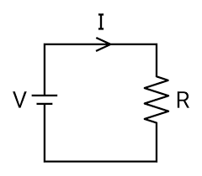
( Figure 1 )

V = voltage
I = current
R = resistance

Ohm's Law, formulated by German physicist Georg Simon Ohm in 1827, serves as a fundamental principle in electrical engineering and physics. It states that the voltage (V) across a resistor is directly proportional to the current (I) passing through it, with the proportionality constant being the resistance (R) of the resistor. Mathematically, Ohm's law is expressed as:

V = IR

where V is the voltage in volts (V), I is the current in amperes (A), and R is the resistance in ohms (Ω).

Resistance, a property of materials that impedes the flow of electrical current, can be quantified using the equation:

R = (ρ × l) / A

where ρ (rho) is the resistivity of the material in ohm-meters (Ω·m), l is the length of the material in meters (m), and A is the cross-sectional area of the material in square meters (m^2).

Resistivity (ρ) is an intrinsic property of materials, representing their inherent resistance to electrical conduction. It is specific to each material and is independent of the material's shape or size. In contrast, resistance (R) depends on both the resistivity of the material and its dimensions, such as length and cross-sectional area.

Experimental verification of Ohm's law involves setting up circuits with known resistors (or components with known resistance) and measuring the voltage across them as a function of the current passing through them. By plotting voltage versus current graphs and analyzing the linear relationship, the resistance of the components can be determined. This experimental approach allows for practical confirmation of Ohm's law and provides valuable insights into the behavior of electrical circuits.

Furthermore, by extending the principles of Ohm's law to materials with different resistivities and dimensions, it is possible to calculate the resistance and resistivity of various conductors. This enables the characterization of materials based on their electrical properties and facilitates the design and optimization of electrical systems in engineering applications.

4. Experimental Setup

4.1. List Of Materials

1. Rheostat x1
2. Nickel Chrome Wire x1 (Ø0.2 mm, L50 cm)
3. Nickel Chrome Wire x1 (Ø0.4 mm, L 50cm)
4. Copper Wire x1 (Ø0.5 mm, L200 cm)
5. DC Voltage Source (0 – 30 V range) x1
6. Digital Multimeter x2
7. Connection cables
8. Banana Plug to Crocodile Alligator Clip

4.2. Procedure

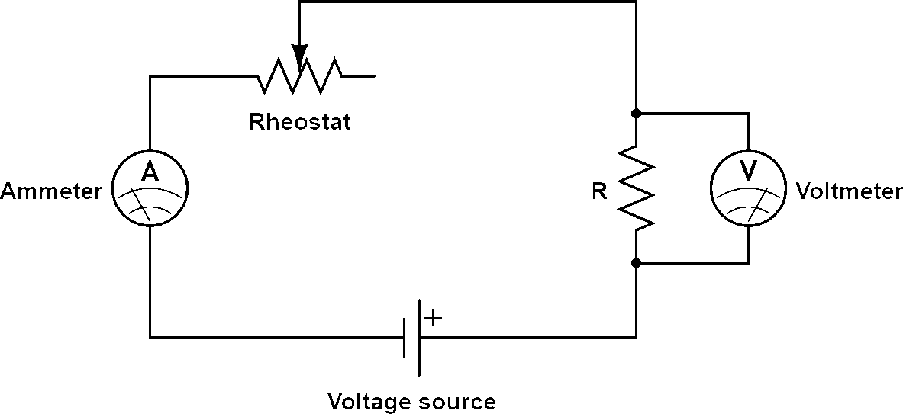
Figure2 . Circuit diagram for wires

1. If not provided, measure the length of the wires with a ruler and record it.
2. If not given, measure the diameter of the wires with a micrometer and record it.
3. Connect the ammeter in series as shown in Figure 2.
4. Connect the voltmeter parallel to the cable.
5. Set the voltage of the power supply to 5 volts.
6. Increase or decrease the terminal voltage between 0 and 5 volts by the 0.5-volt step value.
7. Read the current value and potential differences across the wire from the multimeters for each step, and record the table.
8. For the Ohm's law experiment, set up the circuit shown in Figure 3. Use rheostat as resistor.
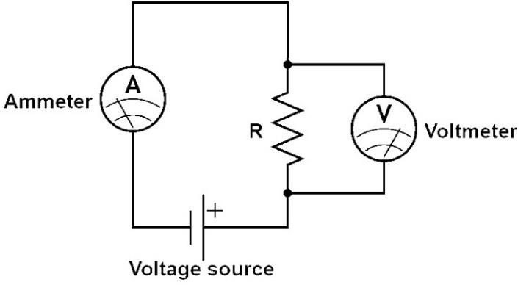
3 Ohms law circuit Figure

9. Measure the real value of resistance of the rheostat.
10. Repeat step 6. Write values to the table of the rheostat.
11. Plot voltage versus current graph for each table.
12. Apply linear curve fit to the plots.
13. According to equation 1, the slope of this graph gives average resistance value.
14. Calculate the resistance and resistivity for each measurement of wires using equations 1 and 2.
15. Calculate percentage error of resistivity of wire.
16. Calculate percentage error of resistance of rheostat.

5. Calculations and Results

5.1Tables

Type of Wire: Nickel Chrome Wire
Length (m):50 cm
Diameter (mm):0.2 mm

 | Vs | VL(mV) | I(mA) | R(Ω) | ρ(Ω.m)
1 | 5 | 0,142 | 0,138 | 1,0002 | 0,5001
2 | 4.5 | 0,128 | 0,1252 | 1,0002 | 0,5001
3 | 4 | 0,114 | 0,1118 | 1,0002 | 0,5001
4 | 3.5 | 0,099 | 0,0978 | 1,0002 | 0,5001
5 | 3 | 0,085 | 0,0839 | 1,0002 | 0,5001
6 | 2.5 | 0,07 | 0,0702 | 1,0002 | 0,5001
7 | 2 | 0,056 | 0,0562 | 1,0002 | 0,5001
8 | 1.5 | 0,042 | 0,0422 | 1,0002 | 0,5001
9 | 1 | 0,028 | 0,0281 | 1,0002 | 0,5001
10 | 0.5 | 0,013 | 0,0141 | 1,0002 | 0,5001

Type of Wire:Nickel Chrome Wire
Length (m):50 cm
Diameter (mm):0.4 mm

 | Vs | VL(mV) | I(mA) | R(Ω) | ρ(Ω.m)
1 | 5 | 0,481 | 0,182 | 2,659 | 1,1295
2 | 4.5 | 0,438 | 0,1644 | 2,659 | 1,1295
3 | 4 | 0,389 | 0,1462 | 2,659 | 1,1295
4 | 3.5 | 0,341 | 0,1278 | 2,659 | 1,1295
5 | 3 | 0,292 | 0,1093 | 2,659 | 1,1295
6 | 2.5 | 0,243 | 0,0902 | 2,659 | 1,1295
7 | 2 | 0,191 | 0,072 | 2,659 | 1,1295
8 | 1.5 | 0,143 | 0,0535 | 2,659 | 1,1295
9 | 1 | 0,095 | 0,0362 | 2,659 | 1,1295
10 | 0.5 | 0,047 | 0,0178 | 2,659 | 1,1295

Type of Wire:Copper Wire
Length (m):200 cm
Diameter (mm):0.5 mm

 | Vs | VL(mV) | I(mA) | R(Ω) | ρ(Ω.m)
1 | 5 | 36,1 | 198,1 | 0,1833 | 0,3666
2 | 4.5 | 32,8 | 178 | 0,1833 | 0,3666
3 | 4 | 29,2 | 157,9 | 0,1833 | 0,3666
4 | 3.5 | 25,2 | 136 | 0,1833 | 0,3666
5 | 3 | 20,9 | 112,9 | 0,1833 | 0,3666
6 | 2.5 | 17,3 | 93,6 | 0,1833 | 0,3666
7 | 2 | 13,8 | 75,3 | 0,1833 | 0,3666
8 | 1.5 | 10,3 | 55,9 | 0,1833 | 0,3666
9 | 1 | 6,8 | 37,3 | 0,1833 | 0,3666
10 | 0.5 | 3,3 | 18,6 | 0,1833 | 0,3666

Rheostat:

 | Vs | VL(mV) | I(mA)
1 | 5 | 2,7 | 3,95
2 | 4.5 | 2,33 | 3,48
3 | 4 | 2,03 | 3,02
4 | 3.5 | 1,74 | 2,55
5 | 3 | 1,43 | 2,09
6 | 2.5 | 1,12 | 1,62
7 | 2 | 0,864 | 1,53
8 | 1.5 | 0,648 | 1,37
9 | 1 | 0,431 | 0,918
10 | 0.5 | 0,216 | 0,458

6. Discussion and Conclusion

In conclusion, this experiment successfully demonstrated the principles of Ohm's law and provided practical experience in electrical circuit analysis. By measuring voltage and current for various components, we confirmed the linear relationship between these parameters and determined the resistance values using experimental data. Additionally, the calculation of resistivity allowed us to further characterize the materials used in the experiment.

Overall, the results obtained support the fundamental concepts of electrical circuit theory and reinforce the importance of accurate experimentation and data analysis in scientific investigations. Through this experiment, we gained a deeper understanding of Ohm's law and its application in real-world electrical systems.

7. References

- https://canvas.instructure.com/files/245848687/download?download_frd=1
- https://canvas.instructure.com/files/246448194/download?download_frd=1

8. Appendix

Experiment Sheet

